15) Create a Cloning of a VM and Test it by loading the Previous Version/Cloned

VM

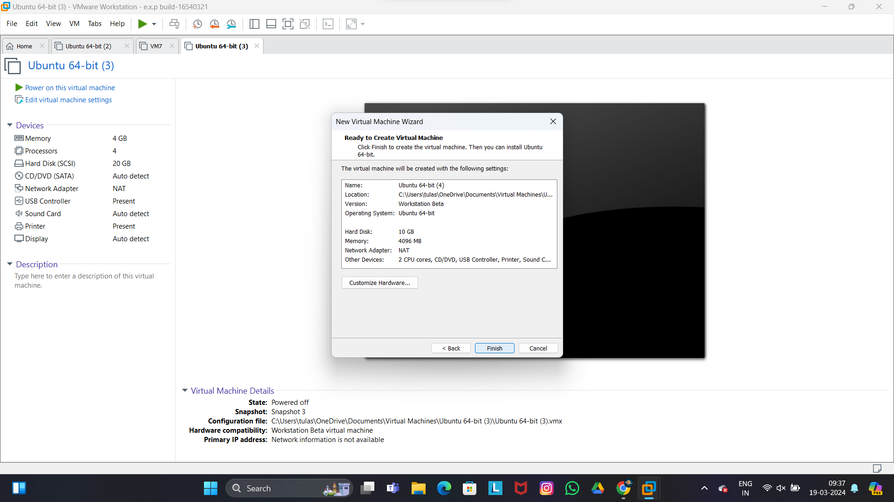

Step 2

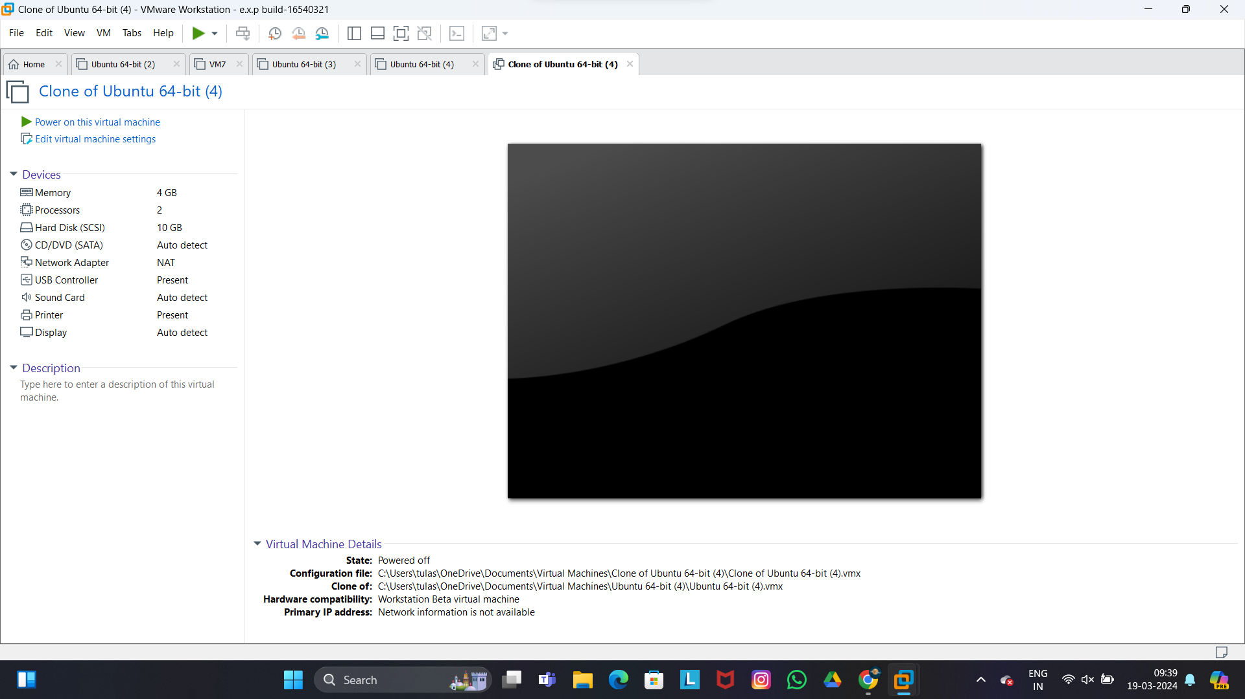

Step 3

